PHY 131 Spring 2017

Units I-IV

Practice Problems

1. A person weighs a fish of mass m on a spring scale attached to the ceiling of an elevator, as illustrated in the figure below. Show that if the elevator accelerates either upward or downward, the spring scale gives a reading that is different from the weight of the fish. (Example 5.8, p.128, HRW 8TH ed.)

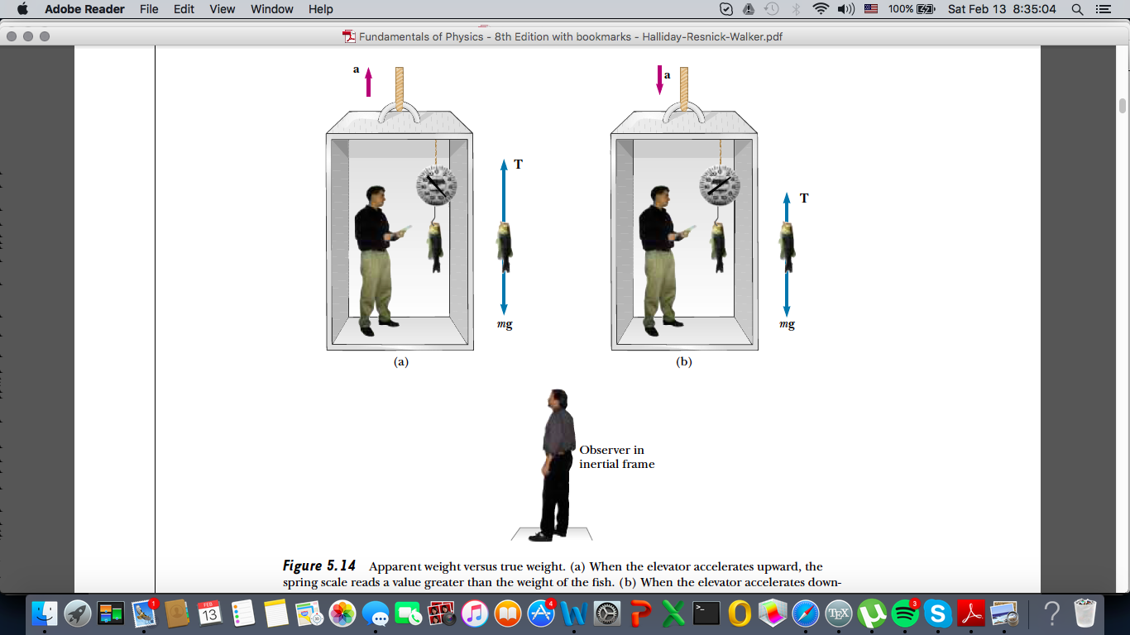

2. Determine the stopping distance for a skier moving down a slope with friction with an initial speed of 20.0 m/s. Assume μ= 0.180 and θ=5.00°.

3. Skiers are always relevant in February! Imagine we have another skier with m=40kg moving down a slope with θ=10°. Draw a free body diagram including all forces acting on the skier and determine a coordinate system (x-y). Find the force on the skier due to the wind when (a) he is moving with constant velocity.

(b) his velocity is increasing at a constant rate of 1.00 m/s2. (5.36, HRW 8th ed.)

4. Some practice with derivatives:

(a) If y(x) = xe2x+3, then y’ =

(b) If y(x)=4x5e4π, then y’=

5. For a horizontal spring-mass system complete the table using either 0 or maximum for each value. We will call the maximum displacement to the right A and the maximum displacement to the left –A. (Note: this is just notation)

|  |  |  |  |
| --- | --- | --- | --- |
|  | x=-A | Equilibrium x=0 | x=+A |
| Position (x) |  |  |  |
| Velocity (v) |  |  |  |
| Acceleration (a) |  |  |  |
| Force of the spring (F) |  |  |  |
| Momentum (P) |  |  |  |

6. A SkyLab astronaut discovered that while concentrating on writing some notes, he had gradually floated to the middle of an open area in the spacecraft. Not wanting to wait until he floated to the opposite side, he asked his colleagues for a push. Laughing at his predicament, they decided not to help, and so he had to take off his uniform and throw it in one direction so that he would be propelled in the opposite direction. Estimate his resulting velocity. (Example 9.1, p.254, HRW 8th ed.)

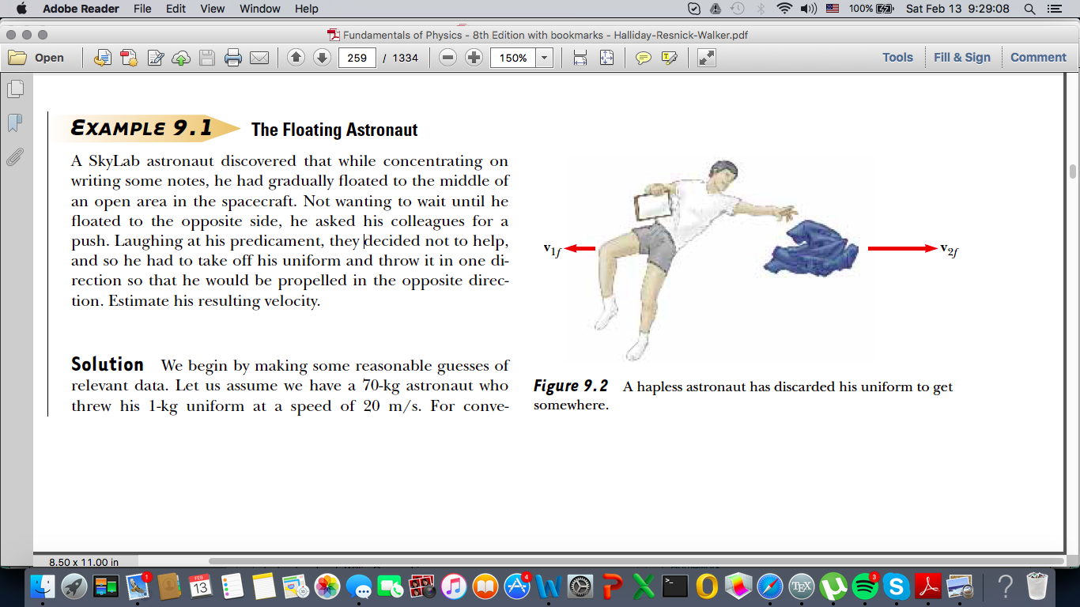

Questions?

[lehung] [penglinq] [mitrouan17]

Mentor sessions: Sundays 7pm, Wednesdays 9pm in Noyce 0506